History of Afghanistan

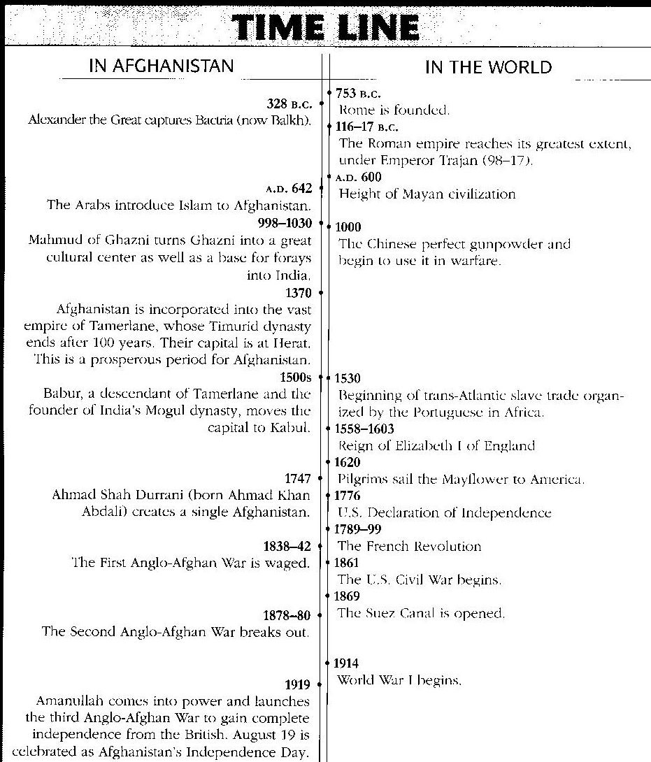
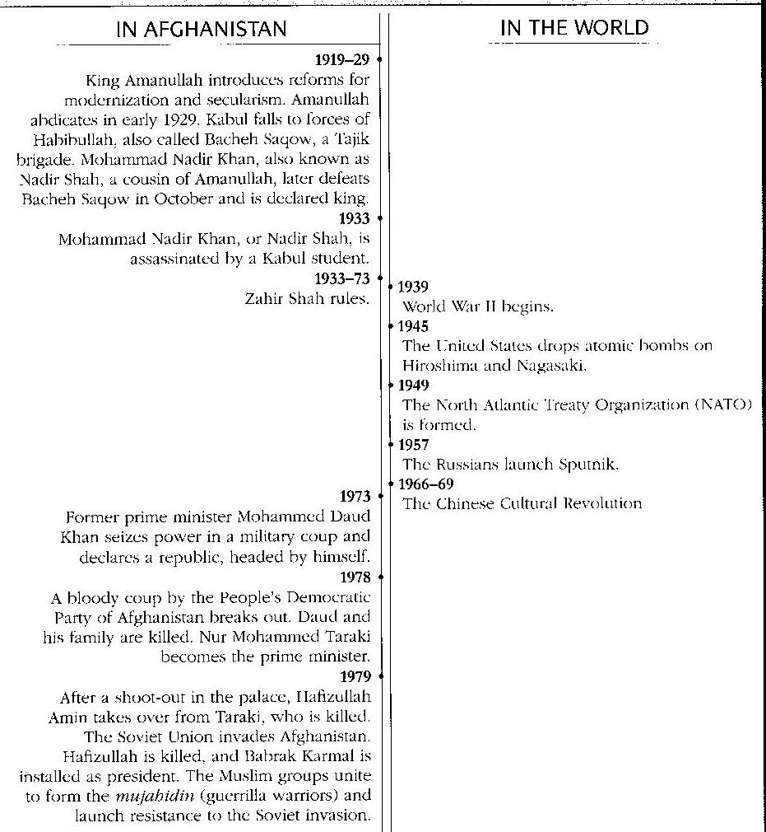

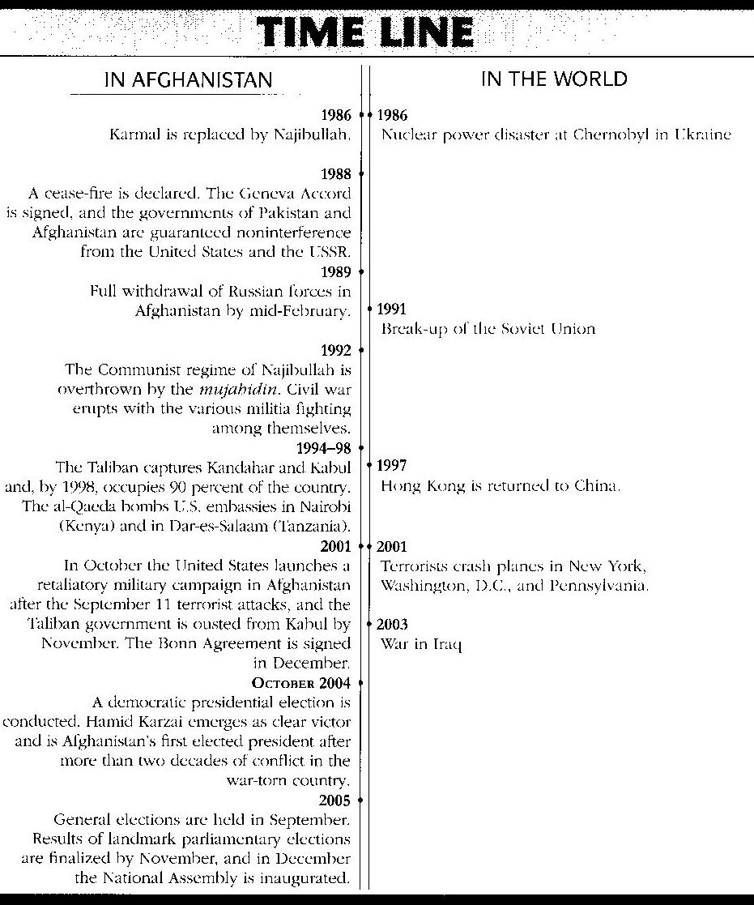

Use the time line to answer the following questions:
- What is the first year provided in Afghanistan’s history?
  - Who captured Bactria?
- In A.D. 642 what religion is brought to Afghanistan?
- Who does Afghanistan gain independence from in 1919?
- What nation invades Afghanistan in 1979?
  - What is the mujahidin?
- By what year does the Taliban capture Kandahar and Kabul and control 90% of the country?
- What happens “In The World” in 2001?
- How does this event affect Afghanistan?
- By November of what year is the Taliban removed from power?
- What major even in Afghanistan’s history occurs in October 2004?
- How can you generalize Afghanistan’s history from 1838-2003?

