Political Cartoons

Read pages 159 “The Free Market Economy” (first paragraph) and 169-170 “Economic Ties”
Discuss the following questions to help you with your task.

- What is a free market economy?
- What is NAFTA? What is its purpose/what did it establish?
- Do you think that trade among the US, Canada, and Mexico will continue to be strong? Explain.
- What is the difference between import and export? Which would be better to do and why?
- Why does the US depend on a trade supply for energy? What major resource do they import?
- Have you ever purchased a foreign-made product that was cheaper than an American-made product? Why do you think the foreign product was cheaper?
- What is the difference between a trade surplus and a trade deficit?

Task:
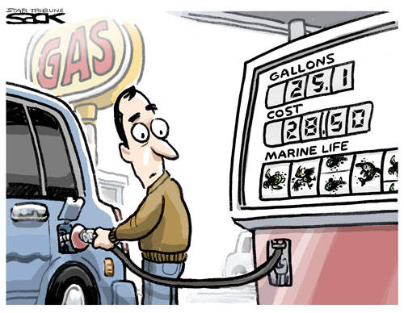
- Create political cartoons about the influence of the US and Canada on the world economy from the topics below (each person needs to take one, if there are more than four people split trade deficit and trade surplus)
- Summarize the main idea or purpose of the cartoon in two sentences.

Topics:
- NAFTA
- Energy Resources
- Trade Deficit (USA)and Trade Surplus (Canada)
- Tariffs

