Vancouver
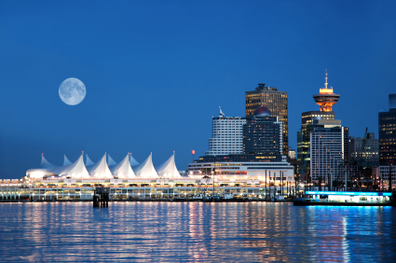
Vancouver – where the ocean meets the mountains. Aside from spectacular natural beauty, Vancouver has a laid-back charm that makes it one of the most popular Canadian cities to visit. It is also one of the busiest ports in Canada. Vancouver is often called “Canada’s Gateway to the Pacific”. Its natural harbor in Burrand Inlet is one of the city’s most important features. Ships can use this port year round because the harbor’s waters never freeze. The port handles nearly all of Canada’s trade with Japan and other Asian nations.
Vancouver has many special features. One is Stanley Park which covers over 1,000 acres and ranks among the largest city parks in Canada. Here you will find Stanley Park Zoo and Vancouver Public Aquarium. Another feature is Vancouver’s Chinatown, one of the largest Chinese communities in North America. This area has many restaurants, gift shops, and night clubs. One other feature of Vancouver is Gastown, the original city center. Gastown’s old brick buildings and cobblestone streets reflect the early days of the city. The area has many antique shops, art galleries, and furniture stores.
Millions of people saw the beauty and wonders of Vancouver on the screens of their TVs in 2010 when the city hosted the Winter Olympic Games. Many of the events took place in Whistler, one of the world's premier ski destinations, and also a summer hotspot for mountain biking, hiking, white water rafting, and horse back riding. One can always find something to do at Whislter.

Montreal
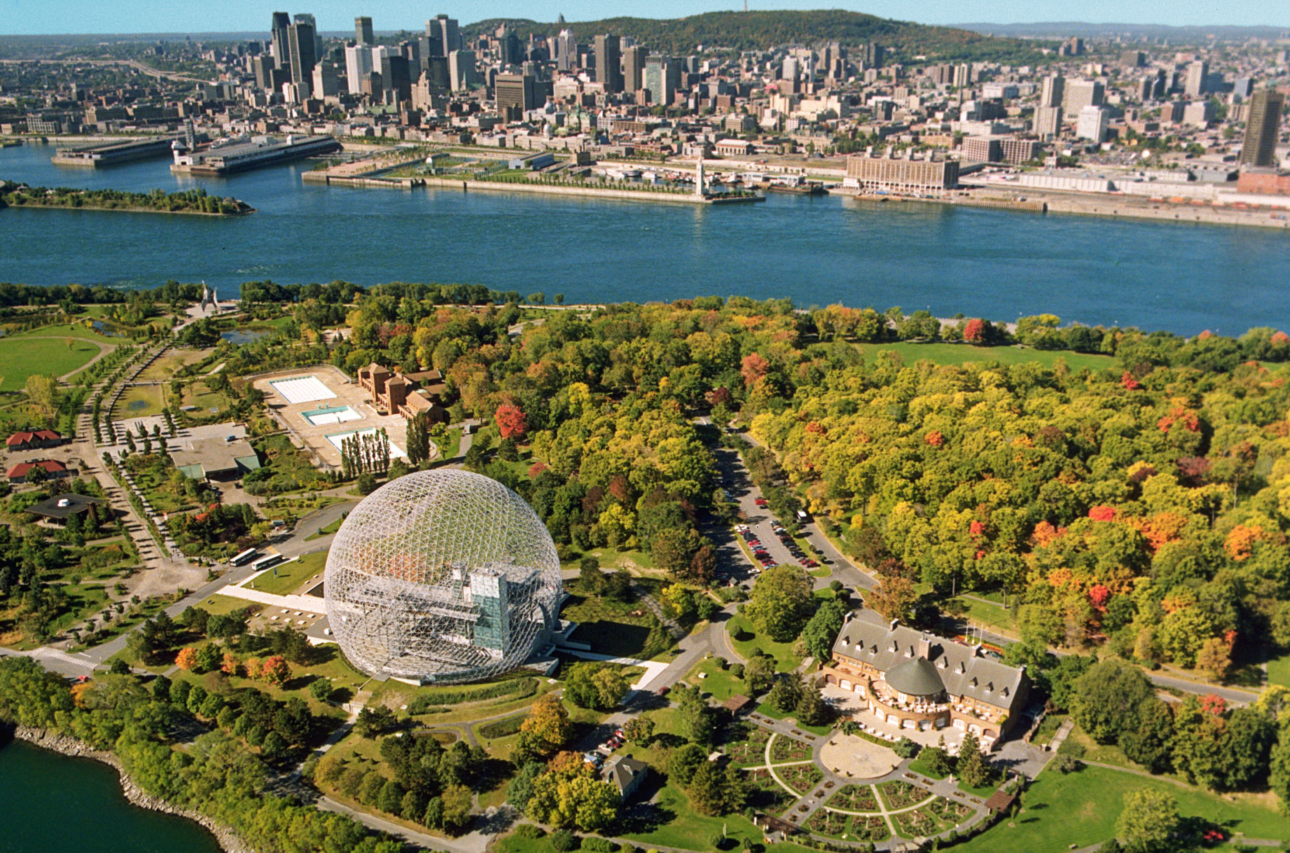
Montreal is a city located on an island. Montreal is Canada’s second largest city after Toronto, and the second largest French-speaking city in the world. Because of its large population, it should come as no surprise to discover that Montreal is a city that is ethnically diverse. Montreal features a Chinatown, a Little Italy, a Little Portugal, and various other neighborhoods adopted by immigrants as their own.
Montreal hosts many special events for people to enjoy. One such event is The Fete des Neiges de Montreal or the Winter Festival. This winter festival features such events as tube sliding, the zip-line, dog sledding, snow-shoeing, cross-country skiing, boot and ice hockey, snow-scootering, and skating along the river. Another great event is Les FrancoFolies de Montreal, the largest French music event in the world. This event attracts close to a million visitors each year and displays every music genre from folk to rock. Other events held in Montreal are Just for Laughs – the world’s largest comedy festival, the Montreal World Film Festival, and the Montreal Fireworks Festival.
Sports have played an important role in Montreal’s history. The city is host to the Montreal Canadiens of the National Hockey League, the Montreal Alouettes of the Canadian Football League, and the Montreal Impact of Major League Soccer. Montreal was the host city for the 1976 Summer Olympics which will always be remembered for Nadi Comaneci’s perfect score in gymnastics.

Quebec City
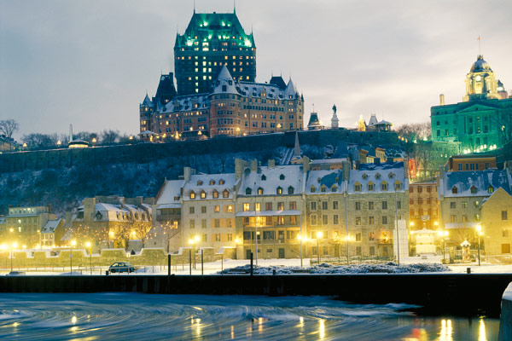
Quebec City offers an experience unlike any other in North America. Stepping into Quebec City is like stepping into Europe. Quebec City is Canada’s oldest city as well as the capital of the province of Quebec. The city is located on top of a cliff above the St. Lawrence River. Quebec City’s Old Town is a walled section of the city. This area itself is a work of art: cobblestone walkways, well-preserved 17th century architecture, café culture and the only North American fortress walls that still exist north of Mexico. Touring the streets of Old Towne gives one the feeling of touring in Europe.
Two of Quebec City’s largest events are the Winter Carnival and the Summer Festival. The Winter Carnival, held at the beginning of February, is one of the largest winter carnivals in the world. Many outdoor activities and competitions are held and a parade takes place each night. Hundreds of artists gather each year to take part in the International Snow Sculpture Show, and a must-see is the Ice Palace which is lit up each evening with an array of lights. Visitors to the Winter Carnival might even stay a night at the famous Ice Hotel and sleep in a bed made of ice. The Summer Festival is the largest Francophone festival in North America. This music festival lasts for 11 days and takes place during the first two weeks of July. The festival developed to show the artistic, economic, and touristic potential of the region.
Other attractions in and around Quebec City are Montmorency Falls Park, an awe-inspiring waterfall higher than Niagara Falls; the Plains of Abraham, Battlefields Park; Parliament Hill; and Fairmont Le Chateau, the world’s most photographed hotel. Quebec City is a city not to be missed.

Calgary
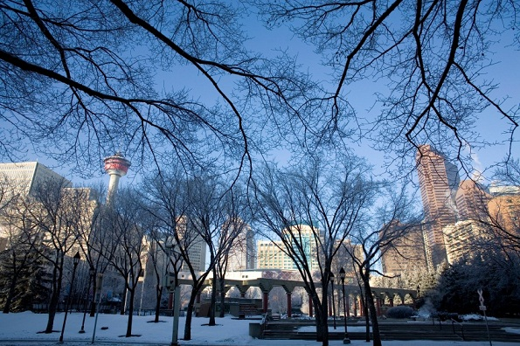
The Calgary Stampede put Calgary on the map and the city's role as the first Canadian city to host the Winter Olympics (1988) solidified its place as one of Canada's top destinations. The Old West spirit is alive and well in Calgary where cowboy hats and line dancing are always in fashion. The city has enjoyed great wealth since the 1990s. The third largest city in Canada is located on the prairie at the eastern edge of the Rocky Mountains. It is well-known for oil and agriculture production.
The Calgary Stampede is a ten-day festival filled with rodeos, performances, and parades. Every July, over one million people attend this event known to Canadians as “the Greatest Show on Earth.” In July, store fronts are painted cowboy themed, residents dress up in western wear, and pancake feeds and barbeques are abundant. The festival starts out with a giant parade of over 150 floats and horses from around the world. Cowboys, First Nations dancers (Native Americans of Canada), Mounties (Canada’s Royal Mounted Police), rodeo clowns, bands, and famous Canadians make up the parade. This is the largest rodeo in the world. Winners of each event (men and women’s bull riding, barrel racing, steer wrestling, tie down roping, saddle bronc riding, and bareback riding) win $100,000. Teams also compete in covered wagon races. Demonstrations of Native American culture (such as pow wows, teepees, arts and crafts, and music) and horse, cow, and agriculture activities take place along with carnival games, and performances by country singers such as Garth Brooks.
You can’t visit Calgary without marveling at the Canadian Rockies, and specifically Banff National Park. Canada’s oldest national park will take your breath away as you gaze at the jagged Rocky Mountains, slowly moving glaciers, dense forests, turquoise colored glacial lakes, and abundant wildlife (grizzly and black bears, cougars, lynx, wolverines, wolves, elk, moose, mountain goats, beavers, and bald eagles). Here you can hike, canoe/kayak, ski, camp, or ride the Canadian Pacific Railway through the scenic landscape. Calgary provides the best of both worlds, the vibrant cultural side of Canada (modern, western, and Native American) along with the incredible natural beauty.
Edmonton


Edmonton is the northernmost major city in North America and is called the Gateway to the North. Its location makes it a major distribution point for goods traveling to and from Alaska and northwestern Canada. The city is a major refining, manufacturing, and distribution center for Alberta's petroleum and petrochemical industry.

Edmonton is the capital of Alberta and is probably best known as a city of festivals, the two most famous being the Edmonton Folk Music Festival, an annual four-day outdoor music event held the second weekend of August, and the Edmonton International Fringe Theatre Festival. The Fringe Festival is held every August and is the oldest and largest Fringe Theatre Festival in North America. The emphasis is on theatre with 1,500 performers taking part each year. During the festival, the streets and alleys are filled with street performers and masked or costumed actors promoting their plays. Festivals take place throughout the year in Edmonton celebrating music, visual arts, dance, performing arts, film, and even winter.

When not participating in a festival another popular attraction in Edmonton is the West Edmonton Mall, the largest shopping mall in North America and the 10th largest in the world. This mall holds 800 stores, 100 restaurants, hotels, and world class attractions like Galaxyland and Waterworld, an indoor ice rink, indoor lakes, theaters, hotels, and even a miniature golf course. One can always find something to do in Edmonton.

Ottawa
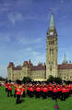
Ottawa, Ontario is Canada's capital city. Ottawa is a charming city to visit; it has a cultured, yet friendly atmosphere. The many historic buildings are lovingly preserved.
The Parliament building is home to the government of Canada. Visitors can see the Washington, D.C. of Canada. Every morning at 10:00 the changing of the guard ceremony takes place. Canadian military members dress in ceremonial uniforms and replace the guard (group of soldiers) who stood watch in at the government building the day before. A military band plays as the guard replaces the previous guard. Make sure to stop by the Prime Minister (leader of Canada) and Governor-General’s (British monarch’s representative) homes to see if you can spot the leaders. Ottawa’s NHL team is named the Ottawa Senators named after the government officials. During the summer months Mosaika takes place, this is the story of Canada through the years. The Parliament building serves as a screen to watch the story of Canada shown through music, lighting effects, and images projected onto the walls. Audiences enjoy an unforgettable 30-minute journey through Canada’s physical, historical, and cultural landscapes as they sit on the grass in front of the government building.
Winterlude is Canada’s largest celebration and is held in Ottawa. This festival celebrates winter the first three weekends of February. Outdoor activities include ice skating, ice sculpting contests, musical concerts, and a huge ice playground. Visitors can enter an ice sculpture museum carved out of snow, view ice sculptures that are lit up at night, and interact with street performers on stilts. During the winter, the Rideau Canal (a water passage) is frozen over and becomes the world’s largest ice skating rink at 5 miles. Other events on the frozen water include a winter triathlon, an annual bed race, hockey game, ice skating performances, and concerts. The Snowflake Kingdom features snow slides, snow sculptures, obstacle courses, sledding areas, and is home to Winterlude mascots.
Another major festival held in Ottawa is Canada Day, also known as Canada’s birthday. Parades, concerts, speeches by government officials, Air Force jet flyovers, and a huge firework display over the Parliament building entertain party-goers. Along with government attractions and festive celebrations, Ottawa is also home to culinary institutes (cooking schools), museums (war, art, nature/science), the Royal Canadian Mint (place were Canadian coins are made and where you can see $1 million in gold bars and can even hold them), and many music and performing art centers.

Toronto
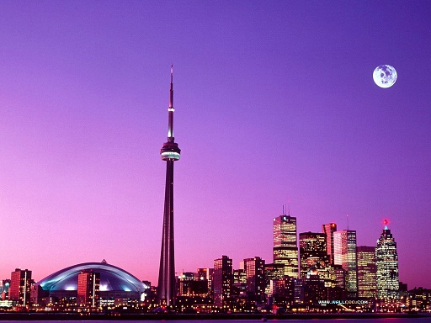
Toronto is probably the best known Canadian city, in large part due to the Toronto International Film Festival, the CN Tower and major sports franchises, including the Blue Jays, the Toronto Maple Leafs, and the Raptors. Toronto is less than two hours from both the U.S. border and Niagara Falls.
You can’t miss the giant CN Tower. This tower is over 1,800ft tall (over 6 football fields in height. Visitors can eat up in the 360 revolving restaurant. You can also walk on the glass floor and look straight down to the ground! If you are really adventurous you can take the EdgeWalk! Here you wear a harness that is attached to a cable and you are allowed to lean over the edge of the walkway with nothing but air between you and the city below!
Back on the ground you can enjoy Royal Ontario Museum that houses over six million items in 40 galleries dedicated to world culture and natural history (such as dinosaurs and animals, minerals and meteorites, art from around the world, and historical documents). Toronto is also home to the Toronto Stock Exchange, Canada’s financial capital, similar to New York’s Wall Street. Here stocks are traded and billions of dollars are traded each day.
If you are hungry head to Toronto the second weekend of August for the Taste of Danforth. During the huge outdoor street festival people enjoy Greek food, culture, and music. A few weeks later in September the Toronto International Film Festival occurs. In 2010, 339 films from 59 countries were shown over the course of 11 days. Many films are shown for the first time at the festival and gain international recognition and sometimes go on to win Oscars at the Academy Awards. If you are interested in hockey you will have to check out the Hockey Hall of Fame and learn about the best hockey players from around the world. Hockey is Canada’s national sport, fitting for the country who invented the game. Lastly make sure to stop by and enjoy a Broadway performance at the Toronto Center for the Arts (musicals, plays, and concerts). Toronto is a must-see city that is full of tourist attractions, festivals, many shopping malls, sporting events, and many ethnic food choices.

