Name_________________________________________ Period _____ Date__________
Character Cluster # 1
Find out the identity and importance of each figure. Then explain how the people relate to one another.

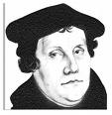 | Martin Luther
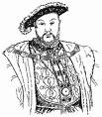 | Henry VIII
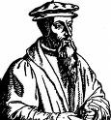 | John Calvin
How do these people relate to one another?

Character Cluster # 2
Find out the identity and importance of each figure. Then explain how the people relate to one another.

 | Henry VIII
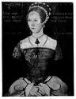 | “Bloody” Mary I
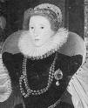 | Elizabeth I
How do these people relate to one another?
Name_________________________________________ Period _____ Date__________
Character Cluster # 3
Find out the identity and importance of each figure. Then explain how the people relate to one another.

 | Elizabeth I
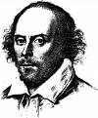 | William Shakespeare
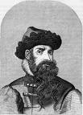 | Johannes Gutenberg
How do these people relate to one another?

Directions: Answer each of the following questions.

1. What was the Renaissance? __________________________________
_______________________________________________________

2. What invention helped spread the ideas of the Renaissance? _________
_______________________________________________________

3. What is an absolute monarch? ________________________________
_______________________________________________________

4. What English monarch refused to share his powers with Parliament? ___
______________________________________________________

5. What happened to this monarch? ______________________________
_______________________________________________________

