Name___________________________________________ Class______ Date_____________________
Interpreting Political Maps

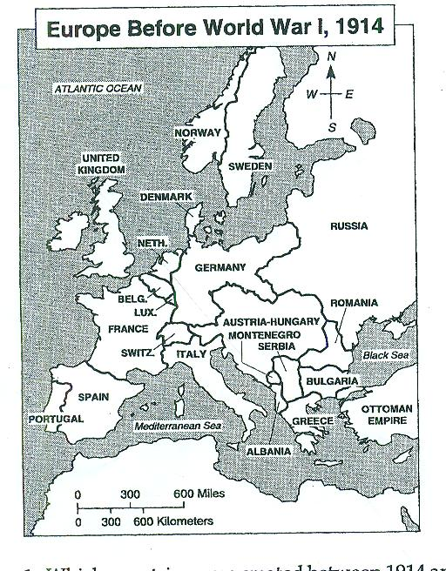
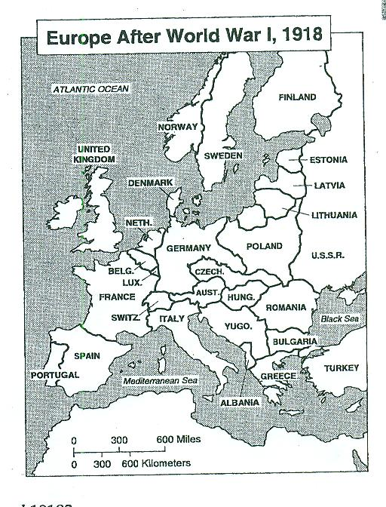

Directions: Compare the two political maps above. Then answer the questions below.

1. Which 10 countries were created between 1914 and 1918? __________________________________

_________________________________________________________________________________

_________________________________________________________________________________

2. What 4 independent countries were formed from the empire of Austria-Hungary?

_________________________________________________________________________________

3. What happened to the political territories of Serbia and Montenegro after World War I?

_________________________________________________________________________________

4. How did the status of Estonia, Latvia, and Lithuania change after World War I?

_________________________________________________________________________________

5. What were two other political changes that took place in Europe as a result of World War I?

_________________________________________________________________________________

_________________________________________________________________________________

_________________________________________________________________________________

