Japan
Japan is a land of great natural beauty. Mountains and hills cover about 70 percent of the country. In fact, the Japanese islands consist of the rugged upper part of a great mountain range that rises from the floor of the North Pacific Ocean. Jagged peaks, rocky gorges, and thundering mountain waterfalls provide some of the country's most spectacular scenery. Thick forests thrive on the mountainsides, adding to the scenic beauty of the Japanese islands.
Japan lies on an extremely unstable part of the earth's crust. As a result, the land is constantly shifting. This shifting causes two of Japan's most striking natural features—earthquakes and volcanoes. The Japanese islands have about 1,500 earthquakes a year. Most of them are minor tremors that cause little damage, but severe earthquakes occur every few years. Undersea quakes sometimes cause a series of huge, destructive waves called a tsunami along Japan's Pacific coast. The Japanese islands have more than 150 major volcanoes. Over 60 of these volcanoes are active.
Numerous short, swift rivers cross Japan's rugged surface. Most of the rivers are too shallow and steep to be navigated. But their waters are used to irrigate farmland, and their rapids and falls supply power for hydroelectric plants. Many lakes nestle among the Japanese mountains. Some lie in the craters of extinct volcanoes. A large number of hot springs gush from the ground throughout the country.
The four main Japanese islands, in order of size, are Honshu, Hokkaido, Kyushu, and Shikoku. Thousands of smaller islands and islets lie near these major islands. Japan's territory also includes the Ryukyu and Bonin island chains.
Japan's four chief islands have 4,628 miles (7,448 kilometers) of coastline. The Pacific Ocean lies to the east and south of Japan. The Sea of Japan washes the country's west coast. It is sometimes called the East Sea because it lies east of Russia and the Korean peninsula.
Honshu, Japan's largest island, has an area of 89,235 square miles (231,118 square kilometers). About 80 percent of the Japanese people live on Honshu.
Three mountain ranges run parallel through northern Honshu. Most of the people in this area live in small mountain valleys. Agriculture is the chief occupation. East of the ranges, along the Pacific, lies the Sendai Plain. West of the mountains, the Echigo Plain extends to the Sea of Japan.
The towering peaks of the Japanese Alps, the country's highest mountains, rise in central Honshu. Southeast of these mountains lies a chain of volcanoes. Japan's tallest and most famous peak, Mount Fuji, or Fujiyama, is one of these volcanoes. Mount Fuji, which is inactive, rises 12,388 feet (3,776 meters) above sea level. The Kanto Plain, the country's largest lowland, spreads east from the Japanese Alps to the Pacific. This lowland is an important center of agriculture and industry. Tokyo sprawls over the southern part of the Kanto Plain. Two other major agricultural and industrial lowlands—the Nobi Plain and Osaka Plain—lie south and west of the Kanto region.
Most of southwestern Honshu consists of rugged, mountainous land. Farming and fishing villages and some industrial cities lie on small lowlands scattered throughout this region.
Hokkaido, the northernmost of Japan's four major islands, covers 30,144 square miles (78,073 square kilometers). It is the country's second largest island but has only about 4 percent of Japan's total population. Much of the island consists of forested mountains and hills. A hilly, curved peninsula extends from southwestern Hokkaido. Northeast of this peninsula is the Ishikari Plain, Hokkaido's largest lowland and chief agricultural region. Smaller plains border the island's east coast. The economy of Hokkaido depends mainly on dairy farming, fishing, and forestry. The island is also a popular recreational area. Long winters and heavy snowfall make Hokkaido ideal for winter sports.
Kyushu, the southernmost of the main islands, occupies 14,114 square miles (36,554 square kilometers). After Honshu, Kyushu is Japan's most heavily populated island, with about 10 percent of the population. A chain of steep-walled, heavily forested mountains runs down the center of the island. Northwestern Kyushu consists of rolling hills and wide plains. Many cities are found in this heavily industrialized area. Kyushu's largest plain and chief farming district is located along the west coast.
The northeastern and southern sections of Kyushu have many volcanoes, high lava plateaus, and large deposits of volcanic ash. In both regions, only small patches of land along the coasts and inland can be farmed. Farmers grow some crops on level strips of land cut out from the steep sides of the lava plateaus.
Shikoku, the smallest of the main Japanese islands, covers 7,049 square miles (18,256 square kilometers). About 3 percent of the Japanese people live on the island. Shikoku has no large lowlands. Mountains cross the island from east to west. Most of the people live in northern Shikoku, where the land slopes downward to the Inland Sea. Hundreds of hilly, wooded islands dot this beautiful body of water. Farmers grow rice and a variety of fruits on the fertile land along the Inland Sea. Copper mining is also important in this area. A narrow plain borders Shikoku's south coast. There, farmers grow rice and many kinds of vegetables.
Monsoons
Seasonal winds called monsoons also affect Japan's climate. In winter, monsoons from the northwest bring cold air to northern Japan. These winds, which gather moisture as they cross the Sea of Japan, deposit heavy snows on the country's northwest coast. During the summer, monsoons blow from the southeast, carrying warm, moist air from the Pacific Ocean. Summer monsoons cause hot, humid weather in the central and southern parts of Japan.
Tsunami of 2011
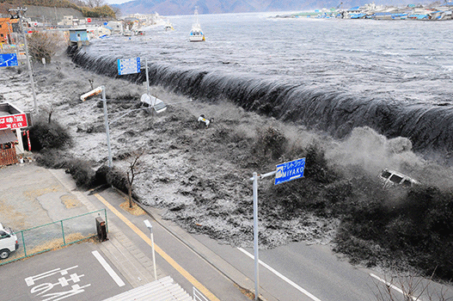
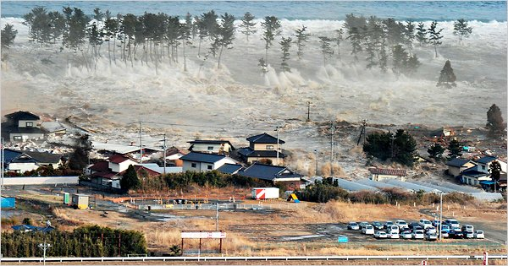
On March 11, 2011, a powerful earthquake struck off the coast of Honshu. The quake created a tsunami that caused widespread destruction. More than 15,800 people were killed, and more than 2,600 others were missing. Hundreds of thousands were left homeless. Water from the tsunami damaged the cooling systems at a nuclear power plant along Honshu’s eastern coast. Nuclear fuel at the plant overheated, leading to the release of dangerous amounts of radioactivity. Plant operators tried to contain the radioactivity and keep the nuclear fuel cool.

Source of Information:
World Book Encyclopedia

