Populaiton Quiz:

Be able to define the vocabulary words related to culture:
population population density
death rate birth rate
life expectancy demography
famine migration
internal migration international migration
urban area rural area
urbanization immigrant
emigrant push-pull theory
refugee

Describe the difference between a densely populated area and a sparsely populated area.

Describe the push-pull theory.

List things that will push a person from their home country and list other things that will pull
people to a new country.

Tell the difference between an immigrant and an emigrant.

Know how to calculate population density for a given area. Remember to round first and
then divide the population by the area.

Know how to read a population pyramid. Practice using the one below.

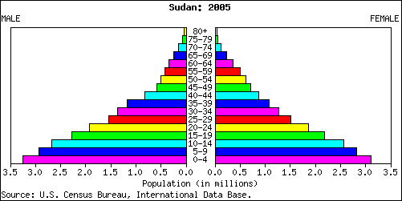

What is the number of boys living in Sudan between the ages of 10-14? _____ Number of girls? ______

What is the total number of children living in Sudan in the age group 5-9? ________________________

Would you say Sudan is developed or developing? ______________________ Explain.

