Cheyenne River Sioux Tribe
Cheyenne River Reservation
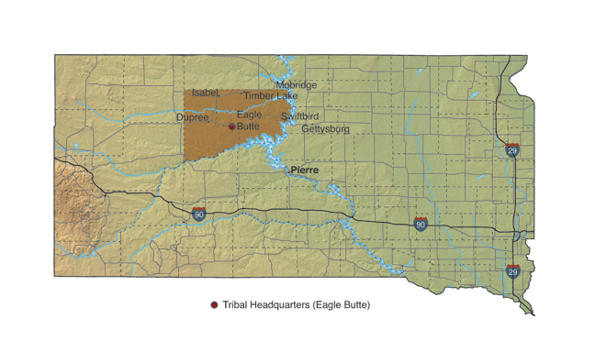

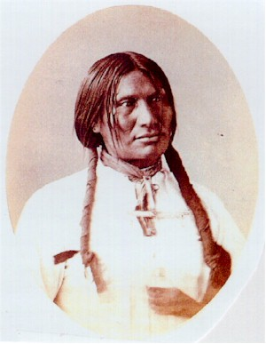
Reservation: Cheyenne River Reservation; Dewey and Ziebach Counties
Division: Teton
Bands: Minnecoujou, Two Kettle (Oohenunpa), Sans Arc (Itazipco) and Blackfoot (Si Sapa)
Land Area: 1.4 million acres
Tribal Headquarters: Eagle Butte, SD
Time Zone: Mountain
Traditional Language: Lakota
Enrolled members living on reservation: 8,000
Major Employers: Cheyenne River Sioux Tribe

Leaders: Past and Present
Big Foot, a Minnecoujou chief, remained true to the "old ways" throughout his life. He was regarded as a wise leader, who respected the individual rights of his people. Big Foot, who had settled on the Cheyenne River Reservation, was killed during the 1890 Wounded Knee massacre. He died under the white flag of truce.

Crow Creek Sioux Tribe
Crow Creek Reservation
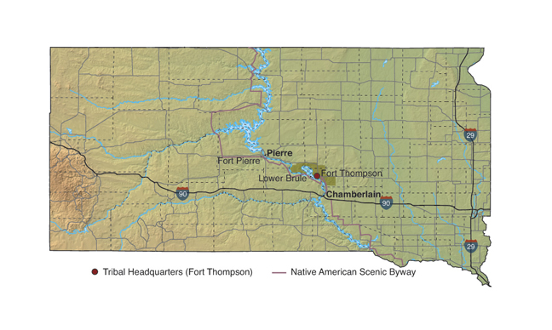
Reservation: Crow Creek Reservation; Buffalo, Hyde, and Hughes Counties
Division: Santee, Yankton
Bands: Mdewakanton (People of Spirit Lake), Ihanktonwan (People of the End)
Land Area: 125,591 acres
Tribal Headquarters: Ft. Thompson, SD
Time Zone: Central
Traditional Language: Dakota
Enrolled members living on reservation: 1,230
Major Industry: Agriculture

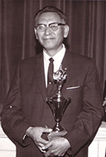

Leaders of the Past
Oscar Howe, a Yanktonai, pioneered a new era in Indian art. Howe was born on the Crow Creek Reservation in 1915. Throughout his life, he received many honors, including the title Artist Laureate of South Dakota. When he died in 1983, Howe left behind a legacy of cultural heritage and pride. More than 20 Oscar Howe originals are on display at the Oscar Howe Art Center in Mitchell.

Flandreau-Santee Sioux Tribe
Flandreau Reservation

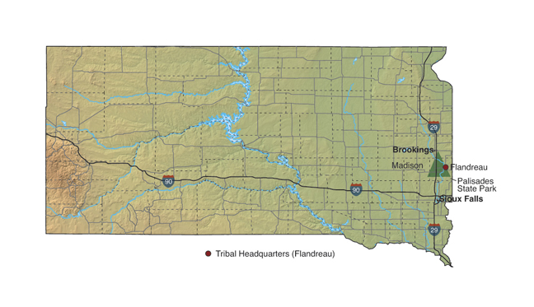
Reservation: Flandreau Reservation; in Moody County
Division: Santee
Bands: Mdewakanton, Wahpekute
Land Area: 2,356 acres (without boundaries)
Tribal Headquarters: Flandreau, SD
Time Zone: Central
Traditional Language: Dakota
Enrolled members living on reservation: 726
Major Employers: Flandreau Indian School, Flandreau Santee Sioux Tribe, Royal River Casino

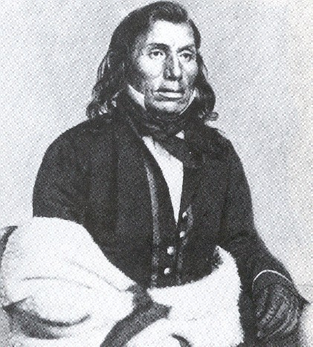
Leaders of the Past
Chief Little Crow spent much of his life in Minnesota, where he was the head of a Santee band. Little Crow, a bold and passionate orator, established himself as a spokesman for his people. After becoming chief around 1834, he sought justice for his people, but also tried to maintain relations with the whites. In 1862, he led the fight now known as the Minnesota Santee Conflict. In fact, this war was launched only in the face of starvation and only after the federal government didn't present land payments as promised. Little Crow was killed the following year. He is buried near Flandreau.
Lower Brule Sioux Tribe
Lower Brule Reservation
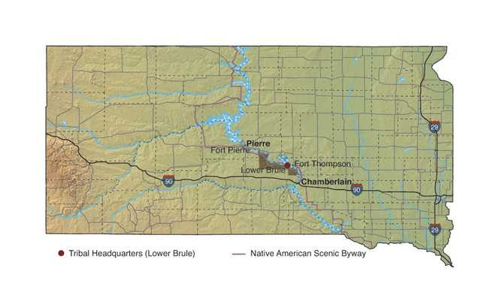
Reservation: Lower Brule Reservation; Lyman and Stanley Counties
Division: Teton
Bands: Sicangu (Brule or Burnt Thigh)
Land Area: 132,601 acres
Tribal Headquarters: Lower Brule, SD
Time Zone: Central
Traditional Language: Lakota
Enrolled members living on reservation: 1,308
Major Employers: Lower Brule Sioux Tribe, Lower Brule Sioux Tribe Golden Buffalo Casino, Bureau of Indian Affairs, Indian Health Service. The Lower Brule Farm Corp. is the nation's number-one popcorn producer.
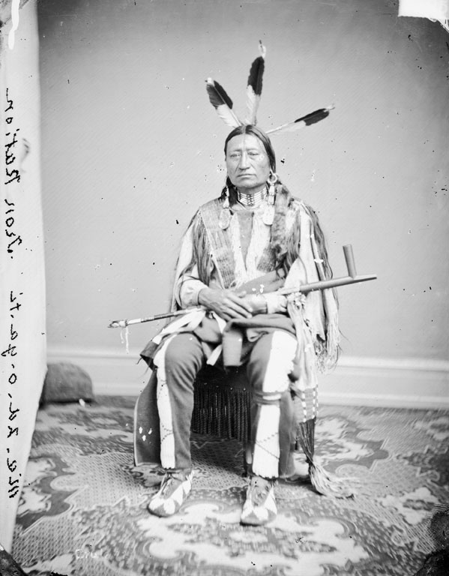

Leaders of the Past
Chief Iron Nation (1815-1894) led the Lower Brule Sioux Tribe through some of its most challenging years. He worked diligently, both as a warrior and statesman, to ensure the survival of his people. Iron Nation signed the treaty to establish the Great Sioux Reservation in 1868. He has been described as a just and noble leader.
Oglala Sioux Tribe
Pine Ridge Reservation
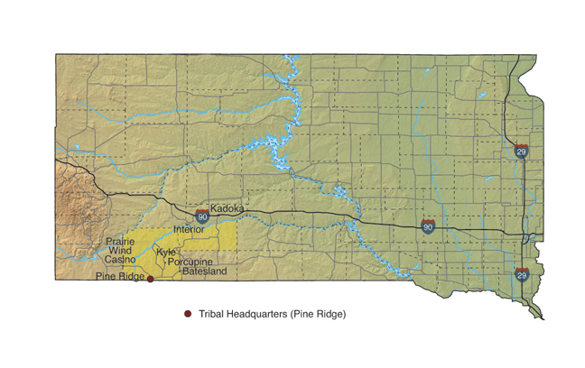
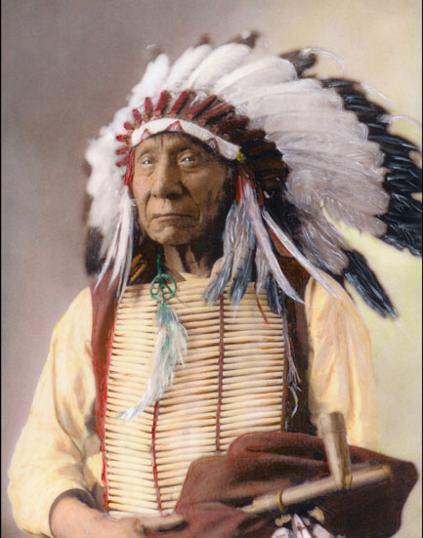
Reservation: Pine Ridge Reservation; Shannon and Jackson County
Tribal Headquarters: Pine Ridge, SD
Time Zone: Mountain
Traditional Language: Lakota
Enrolled members living on reservation: 38,000

Leaders of the Past
Red Cloud, an Oglala chief, was a respected warrior and statesman. From 1866-1868, he successfully led the flight to close off the Bozeman Trail, which passed through prime buffalo hunting grounds. Once settled at Pine Ridge, Red Cloud worked to establish a Jesuit-run school for Indian children. He is buried on a hill overlooking the Red Cloud Indian School, which was named in his honor.
Rosebud Sioux Tribe
Rosebud Reservation
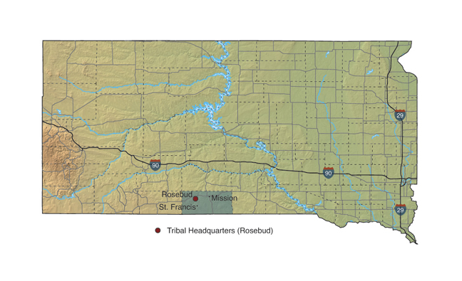
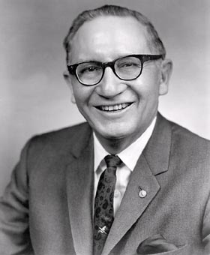
Reservation: Rosebud Reservation; Todd, Mellette and Tripp Counties
Division: Teton
Band: Sicangu (Brule or Burnt Thigh)
Land Area: 882,416 acres
Tribal Headquarters: Rosebud, SD
Time Zone: Central
Traditional Language: Lakota
Enrolled members living on reservation: 21,245
Major Employers: Rosebud Sioux Tribe, Bureau of Indian Affairs, Todd County School District
Leaders: Past and Present
Ben Reifel, a five-term U.S. Congressman, was born near Parmelee on the Rosebud Reservation in 1906. During his lifetime, he worked for the Bureau of Indian Affairs, served in the U.S. Army, and received a doctoral degree from Harvard University. Reifel ran for office in 1960 and served until his retirement in 1971. He died in 1990.
Sisseton Wahpeton Sioux Tribe
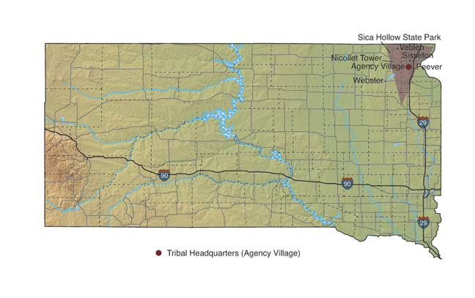
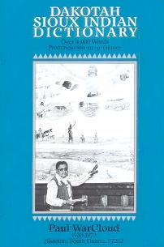
Reservation: Former Lake Traverse; parts of Marshall, Day, Codington, Grant and Roberts Counties
Division: Santee
Bands: Sisseton (People of the Marsh), Wahpeton (People on Lake Traverse)
Land Area: 106,153 acres (without boundaries)
Tribal Headquarters: Agency Village, SD
Time Zone: Central
Traditional Language: Dakota
Enrolled members living within former reservation area: 9,894
Major Employers: Dakota Sioux Casino, tribal government, Bureau of Indian Affairs
Leaders of the Past
Paul War Cloud, a Sisseton-Wahpeton, was born in 1930 near Sica Hollow. A self-taught artist, War Cloud realistically depicted Dakota culture and tradition in his paintings. Many of his works are on display at the Tekakwitha Fine Arts Center in Sisseton. A War Cloud mural, "Unity Through the Great Spirit," hangs at the Cultural Heritage Center in Pierre. War Cloud died in 1973.

Standing Rock Sioux Tribe
Standing Rock Reservation
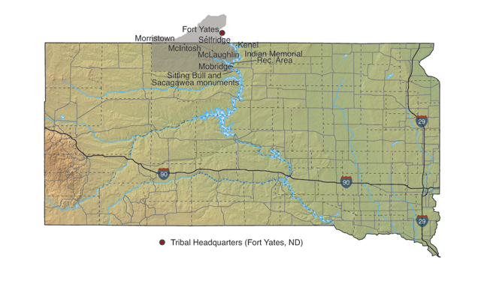
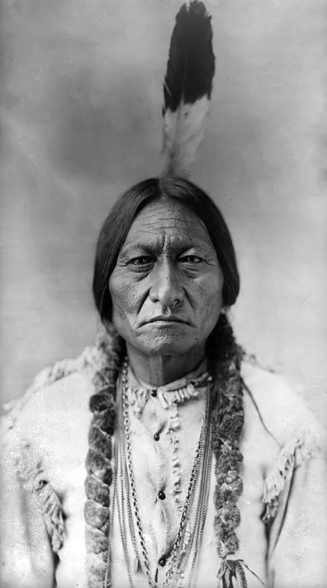
Reservation: Standing Rock Reservation, Corson County SD
Division: Yanktonais, Teton
Bands: Hunkpapa, Blackfeet, Tanktonais and Cutheads
Land Area: 562,366 acres in South Dakota
Tribal Headquarters: Ft. Yates, ND
Time Zone: Mountain (South Dakota side), Central (North Dakota side)
Traditional Language: Dakota and Lakota
Enrolled members living on reservation: 10,133
Major Employers: Standing Rock Sioux Tribe, which administers 40-50 programs, Sitting Bull College, Prairie Knights Casino, Grand River Casino and school districts
Leaders of the Past
Sitting Bull, a Hunkpapa, was an influence and respected man. Not only did he serve as a spiritual leader, he also was the last known leader of the "Cante Tinza," an elite warrior society. Sitting Bull helped to defeat Custer at the Battle of Little Big Horn. And he traveled with Buffalo Bill Cody's "Wild West Show" for a time. Sitting Bull was killed by Indian police on Dec. 15, 1890.
Yankton Sioux Tribe
Yankton Reservation
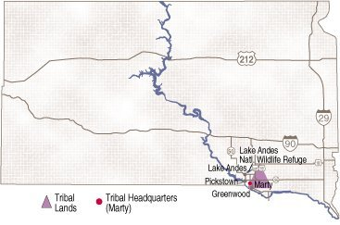
Reservation: Diminished Yankton Reservation; part of Charles Mix County
Division: Yankton
Bands: Ihanktonwan
Land Area: Approximately 40,000 acres (without boundaries)
Tribal Headquarters: Marty, SD
Time Zone: Central
Traditional Language: Dakota
Enrolled members living within diminished area: 3,500
Major Employers: Fort Randall Casino, Indian Health Service, tribal office, Bureau of Indian Affairs, Marty Indian School
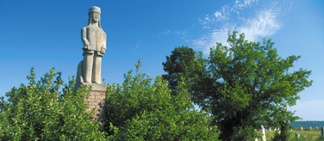
Leaders: Past and Present
Legend has it that when he was born in 1804, Struck By The Ree, a Yankton chief, was wrapped in an American flag by Meriwether Lewis. Lewis and Clark were in the area exploring Louisiana Purchase lands. As a leader, Struck By The Ree managed to befriend the whites, yet remain dedicated and loyal to his people. He died in 1888 at Greenwood. A stone image commemorating this great leader marks his gravesite just north of Greenwood.

