Name_____________________________________________________________ Class__________ Date_____________________________

World Religions: Using a variety of reference materials, complete the chart below.

 | Buddhism | Christianity | Hindu | Islamic | Jewish
Symbol |  | 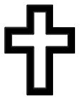 | 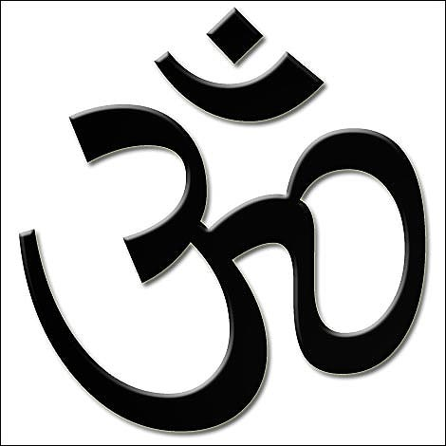 |  | 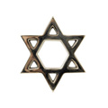
Founder
Sacred Text
House of Worship
Holy Places
Followers
Country of Origin
Holidays or Celebrations

